**CHAPTER ONE**

**INTRODUCTION**

1. **Background of Study**

Today, in our contemporary society it is often a strenuous thing for a student to embark on a search for a place to live, because of this, a lot of students settle for apartments which doesn’t suit their need or are compelled to stay with other students to avoid going on house hunts, which can be very discomforting. This problem is most experienced by new students; however, the old students are not exempted.

Students often face problems during this period such a sexual harassment. (United States Department of Justice Civil Rights Division, Housing and Civil Enforcement Section, 2005) stated that sexual harassment is more likely to occur in rental properties, and this is commonly seen among female students. Also Seagar (1998) Succinctly stressed that female students who move out of the society expectation of their perceived roles may equally experience sexual harassment from the property owners who may perceive them as being sexually available when tying to solve their accommodation problem. Ogundokun (2019) Stressed that hostel management system has become more sophisticated than it used to be in the previous years. Peter A (2017) Stated that a hostel management system is simply a software developed for managing most activities that take place in the hostels with the help of a hostel administrator. Now we created a system where students can easily search for a house, view rooms that are available, choose a roommate if needed, make payments, and settle down in the house. A question comes up, “Can my system solve the problem of sexual harassment amongst the female students?” My system also included a testimonial section where you can report any false treatment that has been giving to you by any land owner. More-over the systems opens the user to multiple choices, such that the user can immediately find a house or lodge in a space of 48 hours if the present one is not suitable for him/her.

Hostel is an establishment which provides cheap lodging for specific group of people especially students, it is also seen as a home for students when staying away from their home. Hostel allocation systems are computerized processes that manage the assignment of rooms in hostels and other accommodations. According Ali et al (2018), these systems offer a faster, more accurate and efficient way to assign rooms to students and other residents. The demand for student’s accommodations in universities and other institutions has increased over the years, which has led to the need for better ways of managing room allocation. As a result, there has been significant research in recent years on the development and implementation of hostel allocation systems.

Research has shown that the traditional manual approach to hostel allocation is prone to errors and time-consuming. According to Haruna et al (2016), in his study he stated that manual allocation takes a lot of time and it is difficult to keep track of the assignments. Computerized allocation systems have been developed to automate the process of assigning rooms to students and other residents. These systems are designed to optimize the allocation process and provide better room assignments.

Schirmann (1912) created the first permanent youth hostel. These first youth hostel were an exponent of the ideology of the german youth movement to let poor city youngsters breathe fresh air outdoors.

One area of research has been the development of algorithms that can optimize the allocation process. Lui et al (2019) proposed an optimization algorithm that takes into account the preferences of students, the availability of rooms and other factors to improve the allocation process. Another area of research has been the design and implementation of user-friendly interfaces that make it easier for administrators to manage the allocation process. Ali et al (2018) also stressed that “the success of any allocation system depends on its user interface, which should be user-friendly, easy to understand, and navigate.”

Overall, the research on hostel allocation system as sought to address the challenges faced by institutions I managing the allocation of hostel rooms to students and other residents. By developing more efficient and effective allocation systems institutions can improve the student experience and enhance the overall quality of their services. Salihu el al (2016) noted, “the use of computerized allocation systems can help reduce the workload of administrators and ensure that students are assigned to suitable rooms.

1. **Statement of the Problem**

The demand for student accommodation in Universities and other institutions has been increasing over the years, leading to challenges in managing the allocation of hostel rooms to students. Traditional manual methods of hostel allocation are time consuming and prone to errors, and the process may not always be fair or transparent. Although computerized hostel allocation systems have been developed there is still a need for further research to optimize the allocation process and improve the user experience for both students and administrators.

The growing number of students in higher institutions all over the world has posed a lot of accommodation problem on the part of students and school management.

1. **Objectives of the Study**

* To evaluate the current state of hostel systems in universities and other institutions and identify the challenges and limitations of the existing systems
* To develop an improved hostel allocation system that takes into account the preferences of the students, the availability of rooms, and other relevant factors to optimize the allocation process.
* To test the effectiveness of the improved hostel allocation system in a real-world settings and compare it to existing systems I terms of efficiency, transparency and user satisfaction.
* To assess the scalability and adaptability of the Improved hostel allocation system and its’ ability to handle a large number of students and complex allocation scenarios.
* To design and implement a user-friendly interface for the improved hostel allocation system that makes it easy for administrators to manage the allocation process and for students to view and select their room preferences.
* To provide recommendations for the implementation and adoptions of the improved hostel allocation system in Universities and other institutions, taking into account factors such as cost, feasibility and sustainability.

1. **Research Questions**
2. What are the main challenges and limitations of existing hostel allocation systems in Universities and other institutions?
3. What are the key factors that influence the allocation of hostel rooms to students, such as preferences, availability of rooms, and administrative policies?
4. How can the allocation process be optimized to improve efficiency, fairness, transparency and user satisfaction?
5. What are the design and implementation considerations for a user-friendly interface for hostel allocation system?
6. What are the best practices for the implementation and adoption of an improved hostel allocation system in universities and other institutions?
7. **Significance of the Study**

This project is aim at enhancing easy, accurate, transparent and fair room allocation to the students of John Bosco Institute of Technology Ibolo Obosi.

1. **Scope and Limitation of the Study**

This study focuses on the development and testing of an improved hostel system for John Bosco Ibolo Obosi institute of technology. The study is limited to the allocation of rooms in hostels and does not cover other accommodation such as apartments or dormitories.

The study will be conducted in a real-world setting, using data from John Bosco institute of technology Ibolo Obosi to test the effectiveness of the improved allocation system. The study will also involve the design and implementation of user-friendly interface for the allocation system, which will be evaluated in terms of its ease of use and effectiveness in facilitating the allocation process.

The study will consider the perspectives of both students and administrators, with a focus on improving the student experience while also reducing the workload of hostel rooms. The study will also be limited in terms of time and resources, with focus on developing a proof-of-concept for the improved allocation system rather than fully functional implementation.

1. **Definition of Terms**

**Students:** Someone who is learning a school or other educational institution.

**Hostel:** is a form of low-cost place where guests can rent a bed, usually a bunk bed in a dormitory.

**Allocate:** To give a portion of something to an individual

**Hostel Management System:** is a software developed for managing various activities in the hostel. It helps hostel admin in managing records of the hostel in an efficient manner.

**System:** A set of detailed methods, procedures and routines created to carry out a specific activity, perform a duty, or solve a problem.

**CHAPTER TWO**

**LITERATURE REVIEW**

The review was carried out under the following subheadings:

1. **Conceptual Review:**

* The concept of student hostel allocation system.

1. **Theoretical Framework:**

This study required on theories namely

* The theory Allocation policies and criteria
* Student needs and preferences
* Availability of accommodations
* Support for vulnerable students

1. **Empirical Studies**

* Study of the Existing System
* Proposed System

1. **Recent Development of the Study**
2. **Conceptual Review**
3. **Concept of Student Hostel Allocation System**

The Student Hostel Allocation System is a comprehensive software solution designed to streamline and automate the process of allocating hostels to students in educational institutions. The system aims to efficiently manage the allocation process, ensuring fairness, transparency, and convenience for both students and administrators.

**Definition of Student hostel allocation system:**

A Student Hostel Allocation System is a computer program that helps schools and colleges assign rooms to students who want to live in a hostel or dormitory.

Student hostel management system is a software program designed to manage the activities of allocating students to a hostel and other activities involved in managing the students in the hostel (Azeeta, 2020).

 An E-hostel system is simply software developed for managing most activities that take place in the hostels with the help of a hostel administrator [Prof. Peter A, 2017].

Student hostel management system is a digital tool that automates and streamlines the management of student hostels. It typically includes modules for registration, room allocation, inventory management, communication, security, and maintenance (NavTark, 2023).

It makes the process easier by keeping track of students' preferences, available rooms, and other factors. The system ensures fairness and transparency by using a special algorithm to allocate rooms based on specific criteria like student preferences, academic performance, and room availability.

This system also allows students to apply for hostel accommodation online and keeps them informed about the status of their application. It may even help students find compatible roommates based on shared interests or study habits. The system helps administrators manage hostels more efficiently by providing reports and analytics about allocation trends and occupancy rates.

In summary, a Student Hostel Allocation System is a computer program that simplifies the process of assigning rooms to students in hostels, making it fair, transparent, and convenient for everyone involved.

**Components and Processes of a Student’s Allocation System:**

A Student hostel allocation system includes components and processes that works together to create an efficient and effective student allocation system that simplifies the process of assigning hostel accommodations to students while ensuring fairness, transparency, and convenience.

1. **Student Profile Management:** This component involves capturing and managing information about students, including personal details, academic information, and preferences for hostel accommodation.
2. **Hostel Management:** This component focuses on managing the hostels or dormitories within the institution. It includes maintaining details about available rooms, their capacity, facilities, and any specific requirements.
3. **Application and Request Submission:** Students can submit their requests for hostel accommodation through an online application system. This component handles the submission process, validates the information provided, and ensures all necessary details are captured.
4. **Allocation Algorithm:** This component uses an algorithm or set of rules to allocate rooms to students. The algorithm considers various factors, such as student preferences, academic performance, room availability, and any specific policies or criteria set by the institution.
5. **Allocation Decision and Confirmation:** After the allocation algorithm runs, this component generates the final allocation decision. It communicates the assigned room to the student and provides them with confirmation of their hostel accommodation.
6. **Roommate Matching (Optional):** Some systems offer a roommate matching feature, where students can indicate their preferences for a compatible roommate based on shared interests, study habits, or other criteria. The system matches students who have similar preferences and assigns them as roommates if possible.
7. **Communication and Notifications:** Throughout the allocation process, the system sends regular updates and notifications to students regarding the status of their application, allocation decision, and any other relevant information.
8. **Reporting and Analytics:** This component generates reports and analytics related to hostel allocation, such as occupancy rates, preferences trends, and overall utilization of hostel facilities. These insights assist administrators in making informed decisions and optimizing the allocation process.
9. **System Administration and Maintenance:** This component involves the overall management, maintenance, and administration of the student allocation system. It includes user management, system configuration, data backups, and ongoing technical support.

**Differentiations Between Student Hostel Allocation System and Related Concepts such as Hotel Room Allocation System and Real-Estate**

While there may be some similarities between a student hostel allocation system, a hotel room allocation system, and a real estate allocation system, there are also key differentiations based on their specific contexts and requirements. Here are some differentiating factors:

* **Target Audience:**

Student Hostel Allocation System: Primarily caters to students who require accommodation during their academic years.

Hotel Room Allocation System: Targets general travelers and guests looking for short-term accommodation.

Real Estate Allocation System: Focuses on property management and allocation for long-term rental or sale.

* **Purpose:**

Student Hostel Allocation System: Designed to efficiently assign rooms to students, manage roommate preferences, and integrate with academic scheduling.

Hotel Room Allocation System: Aims to manage bookings, room availability, and guest preferences for hotels and hospitality businesses.

Real Estate Allocation System: Facilitates property listing, tenant management, lease agreements, and sales transactions.

**Booking Process:**

Student Hostel Allocation System: Typically operates within the framework of an educational institution, involving student registration and coordination with academic schedules.

Hotel Room Allocation System: Involves direct bookings by guests through online platforms, travel agencies, or hotel front desks.

Real Estate Allocation System: Primarily focuses on property listings, inquiries, and negotiations between landlords, tenants, or buyers.

* **Amenities and Services:**

Student Hostel Allocation System: May include features tailored to student life, such as common study areas, shared kitchens, and academic support services.

Hotel Room Allocation System: Emphasizes guest services, such as room service, housekeeping, amenities, and facilities like restaurants, gyms, or swimming pools.

Real Estate Allocation System: Primarily deals with the allocation and management of properties, with limited direct involvement in providing specific amenities or services.

* **Contractual Agreements:**

Student Hostel Allocation System: Often involves specific contractual agreements between the educational institution and students, outlining terms, rules, and responsibilities.

Hotel Room Allocation System: Typically involves short-term rental agreements or contracts between the hotel and guests.

Real Estate Allocation System: Focuses on long-term lease agreements or property sale contracts between landlords, tenants, or buyers.

While there may be overlaps in functionalities or technologies used among these systems, understanding the distinct requirements and contexts is crucial in developing appropriate and effective allocation management solutions for each domain.

**Purpose and Goals of Student Hostel Allocation System:**

The purpose of a Student Hostel Allocation System is to effectively manage the allocation of rooms and beds in a student hostel or dormitory setting. The system serves several goals to facilitate a smooth and efficient accommodation process for students. Some of the main purposes and goals of a Student Hostel Allocation System include:

1. **Room Assignment Efficiency**: The system aims to streamline the process of assigning rooms to students based on their preferences, needs, and any specific requirements. It helps ensure that room allocation is optimized to maximize occupancy rates and accommodate as many students as possible.
2. **Fairness and Transparency:** The system promotes fairness and transparency in room allocation by using predefined algorithms or rules to assign rooms. It minimizes bias and ensures that all students have an equal opportunity to secure suitable accommodations.
3. **Roommate Matching:** If applicable, the system may include features to facilitate roommate matching. It considers compatibility factors such as lifestyle preferences, study habits, or mutual interests to create harmonious living arrangements.
4. **Academic Integration:** In some cases, the system may integrate with academic scheduling systems to align room assignments with students' class schedules, ensuring convenience and minimizing travel time.
5. **Administrative Efficiency:** The system helps streamline administrative tasks related to room allocation, reducing manual effort and paperwork. It automates processes such as registration, room assignment, and generating occupancy reports, saving time and resources for hostel administrators.
6. **Enhanced Communication:** The system can serve as a platform for communication between students, hostel staff, and administrators. It may include features like notifications, messaging, or announcements to keep students informed about room assignments, important updates, or policy changes.
7. **Data Management and Reporting:** The system collects and manages data related to student information, room availability, occupancy rates, and preferences. It enables generating reports and analytics to gain insights into hostel utilization, student preferences, and overall operational efficiency.
8. **Customer Satisfaction:** By facilitating a fair and efficient room allocation process, the system contributes to improving student satisfaction and their overall hostel experience. It helps ensure that students are accommodated in rooms that meet their needs, preferences, and comfort levels.

The ultimate goal of a Student Hostel Allocation System is to optimize the allocation process, provide an equitable and transparent experience for students, and support the effective management of student accommodations within a hostel or dormitory environment.

**Advantages of Implementing Hostel Allocation System**

* **Improved Efficiency:** With student hostel management software, institutions can automate and streamline the entire hostel management process, from registration to maintenance. This significantly reduces the time and effort required to manage hostels, freeing up resources for other critical tasks (NavTark, 2023).
* **Enhanced Communication:** Communication is crucial in managing student hostels. Student hostel management software provides a platform for institutions to communicate important announcements and updates to students, ensuring they are always up-to-date with hostel rules and regulations.
* **Better Security:** Student hostel management software provides features such as access control and emergency notifications, ensuring the safety and security of students in the hostels
* **Improved Maintenance:** With student hostel management software, institutions can schedule regular maintenance checks and repairs, ensuring that the hostels are always in good condition.
* Simplify the Check-In and Check-Out Processes: Proof of presence has always been a prime responsibility of hostel administration and the effectiveness of this is critically important. Best hostel management systems like FretBox need to have this as primary feature and simplify this, and should alert in unhappy situations (Ashish, 2023).
* **Convenience:**No need for rush-hours due to ‘first come first serve’, because students can reserve a bed space from wherever they are and come back when convenient or necessary. It also eliminates long queues and cumbersome processes

1. **Theoretical Framework:**

The student hostel allocation system is an important aspect of hostel management, as it determines how students are assigned accommodations. The following theoretical framework outlin­es the key factors that influence the development and implementation of an effective hostel allocation system:

Allocation policies and criteria: Allocation policies and criteria provide guidelines for decision-making that are objective, consistent, and equitable. According to Henderson (2018), "The development of clear allocation policies and criteria ensures fairness and transparency in the distribution of hostel accommodations among students."

Student needs and preferences: Allocating accommodations based on student needs and preferences can help to create a more positive and inclusive hostel environment. As Chen and Li (2021) point out, "Establishing allocation policies and criteria that are based on student needs and preferences can help to create a more positive and inclusive hostel environment."

Availability of accommodations: The availability of accommodations is an important factor that affects the allocation system. According to Davies and Evans (2019), "Allocation policies and criteria must take into account the availability of accommodations, as well as the needs and preferences of the students.

"Support for vulnerable students: The allocation system should also take into account the needs of vulnerable students, such as those with disabilities or mental health issues. As Smith and Johnson (2020) note, "Without clear allocation policies and criteria, there is a risk that accommodations will be distributed unfairly, resulting in dissatisfaction and complaints from vulnerable students."

In summary, an effective student hostel allocation system should be based on clear allocation policies and criteria that take into account student needs and preferences, the availability of accommodations, and support for vulnerable students. By considering these factors, hostel managers can develop an allocation system that is fair, transparent, and inclusive.

1. **Empirical Studies**

The allocation of student hostel accommodations is an essential aspect of hostel management, as it directly affects the living conditions and well-being of students. However, there is limited empirical research on the effectiveness of hostel allocation systems, particularly with regards to fairness and transparency. Therefore, this study aims to investigate the hostel allocation system at a selected university, with a focus on the extent to which the system adheres to clear allocation policies and criteria, takes into account student needs and preferences, and supports vulnerable students.

The findings of this study will contribute to the existing literature on hostel management and allocation systems, and provide insights into best practices for ensuring fairness and transparency in the allocation of student accommodations. Furthermore, the study will offer recommendations for improving the current hostel allocation system, based on the perspectives and experiences of students and hostel managers. Ultimately, the goal of this study is to promote a more positive and inclusive hostel environment for all students.

1. **Study of the Existing System**

The existing system is manual based and need lots of efforts and consumes time. In the existing system we can apply for the hostels online but the allotment processes are done manually. It may lead to corruptions in the allocations. In the allocation process as well as hostel fee calculation ().

Hostel administration work all should be done online which the existing system lacks. The yearly increase of students in the University will definitely bring about data redundancy, human error, bad record keeping and more drawbacks on the long run. Checking of room allocations, enrolling of complaints, student registration, hostel dues registration among others are done physically and requires manual entry. With an online hostel management system, the workload will reduce. The system is user-friendly and GUI- oriented.

1. **Propose System**

The proposed system for a student hostel allocation system aims to streamline and improve the process of assigning and managing accommodations for students in a hostel or dormitory setting. This system would leverage technology to automate and simplify the allocation process, ensuring fair and efficient distribution of rooms to students.

**Key Features of the Proposed System:**

* Student Profile Management: The system would maintain a comprehensive database of student profiles, including personal information, academic details, and preferences for roommates or specific hostel facilities. This information would be securely stored and easily accessible for allocation purposes.
* Room Allocation Algorithm: The system would incorporate an intelligent algorithm to allocate rooms based on predefined criteria such as student preferences, academic year, gender, and special requirements (if any). The algorithm would consider factors like roommate compatibility, proximity to academic buildings, and facilities to ensure optimal room assignments.
* Real-time Availability and Booking: The system would provide real-time information on room availability, allowing students to view and select their preferred choices from the available options. This feature would help students make informed decisions and reduce manual coordination efforts.
* Preference Customization: The system would allow students to customize their preferences within predefined parameters. They can specify their desired floor, room size, or proximity to common facilities like libraries, cafeterias, or sports facilities. This customization would improve student satisfaction and enhance their overall living experience.
* Notification and Communication: The system would automate the notification process, informing students about their room allocations, any changes or updates, and relevant instructions. Additionally, it would facilitate communication between students, hostel staff, and administrators, allowing for seamless coordination and issue resolution.
* Reporting and Analytics: The system would generate reports and analytics to provide insights into room occupancy rates, preferences, and overall hostel utilization. These reports can help administrators make informed decisions regarding resource allocation, maintenance, and future planning.

**CHAPTER THREE**

**METHODOLOGY**

The researcher discussed the procedure for carrying out this study under the following sub-heading:

Research design, area of the study, population for the study, sample and sampling techniques, instrument for data collection, validations of the instrument, reliability of the instrument, method of data collection, method of data analysis.

1. **Research Design.**

Descriptive survey research design was used for this study.

According to Nworgu (2006), the descriptive survey research design is one in which a group of people or items is studied by gathering and analyzing data and drawing conclusion from only a few people or items considered to be representative of the entire population. This design is suitable because the study will rely on responses from individuals.

**Area of the Study.**

The study was carried out at John Bosco Institute of Technology Ibolo Obosi, Anambra State. It consists of three departments namely:

* Mechanical Engineering.
* Electrical Electronics Engineering.
* Computer Information and Technology.

1. **Population for the Study.**

The population for the study comprise all the staff and students from the three departments made up of 10 staff and 90 students.

1. **Sample and Sampling Techniques.**

The sample size for this study on the design and implementation of the teacher evaluation system was determined to be 100 students and some lecturers. Specifically, 90 students and some lecturers were selected from students and some staff from John Bosco Institute of Technology, Obosi, Anambra State.

Nwanna (1981) suggested that for studies with a population in the few hundreds, a sample size of 40% or more would suffice. For populations in the many hundreds, a 20% sample size would be adequate. If the population is in the few thousand range, a 10% sample size would suffice, and for populations in the several thousand range, a 5% or less sample size would be appropriate.

The students and some lecturers were selected from John Bosco Institute of Technology, Obosi Anambra State. The sampling technique employed was proportionate stratified random sampling.

Proportionate stratified random sampling is a technique where the population is first divided into strategies based on the variables of interest. Elements are then randomly drawn from each stratum in a way that maintains the same relative proportion of the strata as in the population (Nworgu, 1991). This sampling technique ensures equal representation of all strata and guarantees the inclusion of minority groups in the population (Ali, 1996; Nworgu, 1991). The institution constituted a stratum, including both the student and lecturer populations. Since the sample size is 100 students to be selected from the population of the Universities. The number of students and lecturers to be selected was determined based on the proportion of the population from the institute. The proportion of the University was calculated by dividing the total selected students by the sample size.

John Bosco Institute of Technology Obosi, has a proportion of 0.1253. To determine the number of students and lecturers to be selected, the sample size is multiplied by the proportion of the institute.

**Instrument for data Collection.**

The Instrument used for data collection was a structured questionnaire captioned Student Hostel Allocation System a Case Study of John Bosco Obosi.

The questionnaire was divided into two parts

**PART I** contains the demographic details of the respondents and description of response type, while **PART II** contains 20 questionnaire items.

The instrument has four points scales.

VGE = 4 points

GE = 3 points

VLE = 2 points

LE = 4 points

1. **Validations of the Instrument.**

In order to ascertain the face validity of the instrument, the researcher gave copies of the instrument to two experts for criticisms. These experts are from the Department of Computer Information and Technology, Anambra state Nigeria. The title of the research questions, purpose of study, research questions and 15 questionnaire items were exposed to these experts from comments, criticisms and corrections. The researcher was advised to increase the items, remove some, restructure others. This was necessary to make sure that the items were capable of measuring what they were expected to measure. Thus the views, criticism and suggestions of these experts led to the modification or restructuring of some items and removal of others, and helped to bring the questionnaire to its present state.

1. **Reliability of the Instrument.**

In order to determine the reliability of the questionnaire used for this study, a trial test was conducted on a sample of 100 students from the Technical institution of John Bosco Onitsha. The internal consistency of the instrument was established with the use of Cronbach alpha method. The score of all the cluster where computed and the internal reliability co-efficient of 0.684 was obtained from the cluster of one, -0.041 was obtained from the cluster of two, 0.815 was obtained from the cluster of three and 0.845 was obtained from the cluster of four a. The value obtained was high enough to convince the researcher that the instrument is reliable for the study. (see appendix H for details).

1. **Method of Data Collection.**

The researcher administered 150 questionnaires to students in the institution. The administration of the questionnaire was carried out as follows: 100 questionnaires were administered to the students of John Bosco Institute of Technology, Obosi. 30 were lost, and 70 were returned. Method of Data Analysis mean scores were used to answer the five research questions while t-test was used to test the four null hypotheses at 0.05 level of significance. T-test was used because the researcher compared the mea opinions of the two groups of respondents involved in the study. A four-point rating responses of Very Great Extent(VGE), Great Extent(GE), Very Low Extent(VLE), Low Extent(LE) were assigned numerical values of 4, 3, 2 and 1 respectively giving a total of 10 and a mea of 2.50. A cut off point of 0.50-1.49 was considered Very Low Extent to the item and 150-2.49 Low Extend while 2.50 to 3.49 was considered Great Extent and 3.50-4.00 Very Great Extent.

1. **Method of Data Analysis.**

Mean scores were used to answer the four research questions. T-test was used because the researcher compared the mean opinions of the two groups of respondents involved in the study, a four-points rating responses of Very Great Extent(VGE), Great Extent(GE), Very Low Extent(VLE), Low Extent(LE) were assigned numerical values of 4, 3, 2 and 1 respectively giving a total of 10 and a mea of 2.50. A cut off point of 0.50-1.49 was considered Very Low Extent to the item and 150-2.49 Low Extend while 2.50 to 3.49 was considered Great Extent and 3.50-4.00 Very Great Extent.

1. **Technology Consideration**

* PHP
* MySQL
* HTML, CSS and Java script
* Third party API: various API’s were used for the development of the student hostel allocation system.
* Google API

1. **Design Specification**

The system is designed with several interactions cues on each web page that makes up the web application (Hostel allocation System). These cues are well defined such as to male several functionalities that the application eposes to collect, insert, process and output data. Access to these functionalities is made possible by the well designed user interface which embodies several technologies such as PHP, java script and MySQL to process dat. The application is built in a modular form where these functionalities are built into modules. Some of the modules are as follows:

* Allocation.php.
* Login.php.
* Addhouse.php.
* Payment.php.

**Output Specification.**

The system is designed in such a way that it efficiently provides output to the user promptly and in a well-organized manner. The format for the several outputs are made available on the output web pages. Output can be found using the following page modules:

* Property.php: This displays out information for the list of available houses.
* Search.php: Also displays the list of the provided information in all the pages
* Feeds.php: This displays the comments that people made about a particular house.

**Input Specification.**

The system is design to accept input details through user logs and user clicks. The data captured through the user keystrokes and clicks are received by specific modules on the system and relayed to the database of the system for processing. Input is collected using the following page modules:

* Login.php: When you log in, you typically provide credentials, such as a username and password, to verify your identity. Once your identity is confirmed, you are granted access to the system, allowing you to perform various actions or access specific resources based on your user privileges.
* Register.php: The process of registering, also known as signing up or creating an account, is typically done to gain access to a system, website, or application for the first time. Unlike logging in, which confirms your identity for subsequent access, registration involves providing your information to establish a new account.

**Database Specification.**

The database system used to implement the back-end of the system is MySQL. Access to the system was made possible by a graphic interface (phpMyadmin). The database name is host_tb and the structure of the data tables in the database are as follows

* admin_tb
* user
* property
* feed
* allocation
* contact_tb

**CHAPTER FOUR**

**SYSTEM DESIGN AND IMPLEMETATION**

In this chapter the results of the data analysis are represented in accordance with the questions that guided the study.

1. **System Design**

Welcome to the fascinating world of system design. Today, we'll delve into the realm of student hostel allocation systems. In this study, we'll explore the intricate process of designing a system that efficiently assigns hostel rooms to students, ensuring optimal utilization of resources and a seamless experience for all.

We'll dive into the core components of the system, such as user management, room inventory, allocation algorithms, and feedback mechanisms. Together, we'll unravel the challenges involved in handling student preferences, managing room availability, and accommodating various constraints like gender preferences and special needs.

Throughout this journey, we'll consider scalability, robustness, and user-friendliness as crucial design principles. By the end, you'll have a solid understanding of how to architect a student hostel allocation system that caters to the unique needs of both students and administrators, streamlining the entire process.

**Application Architecture**

Application architecture provides a structured approach to designing software systems, ensuring they are well-organized, efficient, and adaptable. It serves as a roadmap for developers to construct robust applications that meet the desired functionality while addressing scalability, maintainability, and other critical aspects.

**Use Case**

A use case diagram is a visual representation of the interactions between actors (users or external systems) and a system. It is a type of behavioral diagram in the Unified Modeling Language (UML) that helps depict the functional requirements of a system from a user's perspective. Use case diagrams provide an overview of the system's functionality and help stakeholders understand how the system interacts with its users or external entities. They are commonly used during the requirements gathering and analysis phase of software development to capture user requirements, define system boundaries, and identify key use cases to be implemented. APPENDIX D SHOWS THE USE CASE DIAGRAM

**Data Design**

A data design diagram, also known as a data model or entity-relationship diagram (ER diagram), is a visual representation of the structure and relationships between data entities in a system. It helps illustrate how different entities relate to each other and how data is organized within a database or information system. Data design diagrams provide a clear and concise overview of the data structure, helping stakeholders understand the data requirements and relationships within a system. They serve as a blueprint for database design, data modeling, and the development of database schemas. These diagrams are commonly used in software development, database management, and system analysis to ensure efficient storage, retrieval, and management of data

By visualizing the data entities, attributes, and relationships, data design diagrams facilitate effective communication among stakeholders, enabling them to discuss and refine the data model, validate requirements, and identify potential issues or improvements in the system's data design. APPENDIX E SHOWS THE DATA DESIGN DIAGRAM

**Activity Diagram**

An activity diagram is a behavioral diagram in the Unified Modeling Language (UML) that represents the flow of activities or actions within a system or process. It depicts the sequence of activities, decisions, and concurrent behavior involved in achieving a specific goal or completing a task. Activity diagrams are commonly used to model business processes, software workflows, use cases, and complex system behavior. They provide a visual representation of the sequence of actions, decision points, and concurrent activities involved in a process. By using activity diagrams, stakeholders can understand the overall flow, identify potential bottlenecks or inefficiencies, and validate the correctness of the process or system behavior.

Activity diagrams can also be used to document and communicate complex algorithms, control logic, or business rules within a system. They serve as a valuable tool for developers, business analysts, and other stakeholders involved in system analysis, design, and implementation. APPENDIX F SHOWS THE ACTIVITY DIAGRAM

**Dataflow Design**

Dataflow design, also known as dataflow architecture or dataflow diagramming, is a design technique used to represent the flow of data within a system or process. It focuses on illustrating how data is input, processed, and outputted throughout the system, providing a visual representation of data transformations and interactions.

In dataflow design, the system or process is represented by a network of interconnected components called dataflow nodes. APPENDIX G SHOWS THE DATAFLOW DIAGRAM

**Control Flow Diagram**

A Control Flow Diagram is a graphical representation of the control flow or sequence of activities within a program or system. It focuses on illustrating the order of execution and the decision points that determine the flow of control within the program.

1. **System Implementations**

The Front End: front end development is the part of web development that codes and creates front end elements of a website, which are features that are directly viewable and accessible by the end-user client. The front-end codes used in this application include:

**HTML:** hypertext markup language, is the standard markup language for documents designed to be displayed in a web browser. It can be assisted by technologies such as cascading style sheets (CSS) and scripting languages such as java script, web browsers receive HTML documents from a web server or from local storage and render the documents into multimedia web pages. HTML describes the structure of a web page semantically and originally includes cues for the appearance of the document.

**CSS:** cascading style sheet is a style sheet language used for describing the presentation of a document written in a markup language like HTML CSS is a cornerstone technology of the world wide web, alongside HTML and JavaScript.CSS is designed to enable the separation of presentation and content, including layout, colors, and fonts. This separation can improve content accessibility, provide more flexibility and control in the specification of presentation characters, enable multiple web pages to share formatting by specifying the relevant CSS in a separate CSS file, and reduce complexity and repetition in the structural content

**JavaScript** : JavaScript is a high-level, interpreted scripting language that conforms to the ECMAScript specification. Java script has curly-bracket syntax, dynamic typing, protype-based object-orientation and first-class functions. Alongside HTML and CSS. JavaScript is one of the core technologies of the world wide web. JavaScript enables interactive web pages and is an essential part of web applications. The vast majority of websites use it and major web browsers have a dedicated JavaScript engine to execute it. As a multi-paradigm language, JavaScript supports event-driven, functional, and imperative (including object-oriented and protype-based) programming styles. It has APIs for working with text, arrays, dates, regular expressions, and the DOM, but the language itself does not include any 1/0, such as networking, storage, or graphic facilities. It relies upon the host environment in which it is embedded to provide these features.

**The Back End:** The back end is the code that runs on the server, that receives requests from the clients, and contains the logic to send the appropriate data back to the client. The back end also includes the database, which will persistently store all the data for the application.

The back-end codes used for this application includes:

**PHP:** PHP is a server-side scripting language that is used to develop static websites or dynamic websites or web applications. PHP stands for hypertext pre-processor, that earlier stood for personal home pages. PHP scripts can only be interpreted on a server that has PHP installed. The client computer accessing the PHP scripts requires a web browser only. A PHP file contains PHP tags and ends with the extension "php" The term PHP is an acronym for PHP: hypertext preprocessor. PHP is a server-side scripting language designed specifically for web development PHP can be easily embedded in HTML files and HTML codes can also be written in a PHP file. The thing that differentiates PHP with client-side language like HTML is, PHP codes are executed on the server whereas HTML codes are directly rendered on the browser.

**MySQL:** MySQL is an open source relational database management system (RDBMS) based on structured query language (SQL). It is one part of the very popular LAMP platform consisting of Linux, Apache. My SQL, and PHP. Currently My SQL database is available on most important OS platforms. It runs on BSD Unix, Linux, Windows, or Mac OS. Wikipedia and YouTube use My SQL. These sites manage millions of queries each day. My SQL comes in two versions: My SQL server system and My SQL embedded system.

1. **System Requirements**

Here the researcher describes the in-depth functionality and how the software works.

***Intended audience and intended users:***

***Software scope:***

***There are several types of interfaces that you may have requirement for***

**Hardware:**

Laptops,

Desktop computer,

Personal devices such as mobile phone, Tablets etc.

**Software:**

HTML,

CSS,

Bootstrap,

Java script,

PHP,

MYSQL,

Vs code,

Github,

WAMP server,

Windows 7, 8, 9, 10, 11.

***Communications:*** Wi-Fi, Internet service provider(ISP)

1. **Installation and Testing**

After the completion of this project, various activities were carried out to make sure its functionality is okay and useable. Among all these processes are

**User page:** students can create an account, login, search for a house, edit there account, add information about themselves, communicate with the admin, choose a house (tested okay).

**Admin/ User Management**: Allocate rooms to students, post available Hostels, edit hostel details, delete accounts of the user, delete hostels, get messages from users.

**CHAPTER FIVE**

**CONCLUSION, RECOMMENDATION AND SUMMARY**

1. **Summary**

The study focused on the student hostel allocation system and its importance in ensuring a fair and efficient distribution of accommodation for students. Throughout the analysis, several key aspects and considerations were explored.

The study emphasized the need for transparency in the allocation system. A transparent and well-communicated procedure helps build trust among students and ensures the fairness of the system. Additionally, the study highlighted the significance of equity in the allocation process. Factors such as distance from campus, financial need, and individual circumstances should be taken into account to provide an equal opportunity for all students.

Moreover, the study emphasized the importance of considering student preferences. Accommodating requests regarding roommates, living arrangements, and specific needs contributes to a positive living and learning environment, promoting student well-being.

Furthermore, the study recognized the potential of technology in improving the efficiency and effectiveness of the hostel allocation system. Automated algorithms, online platforms, and data analytics can streamline the process, reduce errors, and lessen administrative burdens.

1. **Recommendation**

* **Centralized Online Platform:** Develop a centralized online platform specifically dedicated to hostel allocation. This platform should be easily accessible, user-friendly, and capable of handling the entire allocation process, from registration to room assignment.
* **Clear and Fair Allocation Criteria:** Establish transparent and well-defined criteria for hostel allocation. Consider factors such as student preferences, academic performance, seniority, special needs, and geographical location to ensure fairness and equitable distribution of hostel rooms.
* **Flexible Room Preferences:** Allow students to indicate their room preferences, such as single, shared, or mixed-gender accommodations. This flexibility ensures that students' individual needs and preferences are taken into account, promoting a comfortable living environment.
* **Prioritize Special Needs:** Implement a system to prioritize students with special needs, including physical disabilities, medical conditions, or other specific requirements. Dedicated rooms or facilities should be available to accommodate these students appropriately.
* **Randomized Assignment Algorithm:** Utilize a randomized assignment algorithm to distribute rooms fairly among students who have similar allocation criteria. This approach minimizes bias and ensures equal opportunities for all students, preventing perceptions of favoritism or discrimination.
* **Efficient Communication Channels:** Establish efficient communication channels to keep students informed throughout the allocation process. Regular updates, notifications, and guidelines should be shared through email, SMS, or the online platform to ensure that students are aware of important dates, procedures, and outcomes.
* **Appeals and Grievance Mechanism:** Implement a robust appeals and grievance mechanism for students who wish to contest their room allocation or report any discrepancies. A dedicated committee should be formed to address such concerns promptly and impartially, providing a fair opportunity for resolution.
* **Feedback and Continuous Improvement:**

Collect feedback from students about their hostel experience, allocation process, and any areas for improvement. Analyze this feedback to identify shortcomings and make necessary adjustments to enhance the overall system, ensuring a student-centric approach.

* **Regular Review and Monitoring:**

Establish a dedicated team responsible for monitoring and evaluating the allocation system's effectiveness on a regular basis. Conduct periodic reviews, assess the system's efficiency, and make data-driven improvements to optimize the allocation process.

* **Integration with Student Information System:**

Integrate the hostel allocation system with the institution's student information system to ensure seamless data exchange. This integration can streamline the process, eliminate duplication of information, and improve overall efficiency.

1. **Suggestion for Further Study**

* **Comparative analysis:** Conduct a comparative study of different hostel allocation systems implemented in various educational institutions. By examining different approaches and their outcomes, it would be possible to identify best practices and areas for improvement. This analysis could consider factors such as transparency, equity, student satisfaction, and the use of technology.
* **Long-term impact assessment:** Investigate the long-term effects of the hostel allocation system on student academic performance, well-being, and overall campus experience. By analyzing data over an extended period, researchers could assess whether the system contributes to student success and identify any areas that may require adjustment.
* **Student perspectives:** Conduct qualitative research to gain a deeper understanding of student perspectives on the hostel allocation process. Interviews, focus groups, or surveys could be used to explore students' experiences, perceptions, and suggestions for improvement. This research would provide valuable insights into the subjective aspects of the system and help address student concerns.
* **Comparative analysis of technology adoption:** Explore the impact of different technological solutions on the efficiency and effectiveness of hostel allocation systems. Compare the outcomes of institutions that have adopted advanced technologies, such as machine learning algorithms or predictive analytics, with those that rely on traditional manual processes. This analysis could shed light on the benefits and challenges associated with technology adoption in this context.
* **Evaluation of policy and criteria:** Assess the effectiveness of specific policies and criteria used in hostel allocation systems. For example, investigate the impact of distance-based allocation policies, financial aid criteria, or roommate preferences on student satisfaction and well-being. This research would provide evidence-based insights for policymakers and administrators to fine-tune their policies.

1. **Conclusion**

In conclusion, the student hostel allocation system plays a vital role in ensuring a fair and efficient distribution of accommodation for students. Throughout this discussion, we have examined the key aspects and considerations involved in this process.

The analysis reveals that an effective hostel allocation system should prioritize transparency, equity, and student preferences. By adopting a transparent and well-communicated procedure, students can have confidence in the fairness of the system, fostering trust and satisfaction among the student community.

Furthermore, equity should be a fundamental principle guiding the allocation process. Factors such as distance from campus, financial need, and individual circumstances should be taken into account to ensure that all students have an equal opportunity to access suitable accommodation.

Additionally, acknowledging student preferences is crucial in promoting a conducive living and learning environment. The system should aim to accommodate students' requests regarding roommates, living arrangements, and specific needs, wherever possible. This personalized approach can enhance student well-being and contribute to a positive campus experience.

Moreover, leveraging technology can greatly improve the efficiency and effectiveness of the hostel allocation system. Utilizing automated algorithms, online platforms, and data analytics can streamline the process, minimize errors, and reduce administrative burdens, ultimately benefiting both students and administrators.

In conclusion, a student hostel allocation system that embodies transparency, equity, consideration of student preferences, and the integration of technology can foster a harmonious living environment and contribute to the overall satisfaction and success of students. It is essential for institutions to continuously evaluate and improve their allocation processes to meet the evolving needs and expectations of their student population.

**FINACIAL ANALYSIS**

|  |  |  |
| --- | --- | --- |
| **S/N** | **Description** | **Amount N** |
| **1** | Data | 15,000 |
| **2** | Printing and binding | 13,000 |
| **3** | Information | 5,000 |
|  | **Total** | **N 33,000** |

**REFRENCES**

Addison-Wesley, 2013. Hampton, David R. 1977. Contemporary Management, McGraw-Hill Series in Management.

Ala‟ Abbadi, Al-Hammadi Y., Abdul-Rahman A. D. and Mior N. Hostel, Business Model, and IIUM Hostel Room Management System: A Conceptual Transformation Proposal Program. (Faculty of Communication and Information Technology International Islamic University Malaysia), Gombak, 53100, Kuala Lumpur, Malaysia (2017) Automated resource management system for hostel allocation (https://iproject.com.ng /computer-science/automated-resource-management-system-for-hostel-allocation) (Accessed May 22, 2019).

Azeeta, M. (2020). Student Hostel Management System. International Journal of Computer Science and Network Security, 20(2), 56-61.

College Hostel Management Software by Initio (2010) Mishra, A.N. (1994). Students and Hostel Life. New Delhi: Mittal publications.

Gombak, 53100, Kuala Lumpur, Malaysia (2017) Automated resource management system for hostel allocation (https://iproject.com.ng /computer-science/automated-resource-management-system-for-hostel-allocation) (Accessed May 22, 2019).

Hostel manager by Laisikwa W.O. (2015) https://searchoracle.techtarget.com/definition/MySQL (Accessed June 23, 2019) https://www.php.net/manual/en/intro-whatis.php (Accessed June 23, 2019) https://www.vocabulary.com/dictionary/hostel (accessed 24, july 2019) https://www.w3schools.com/whatis/whatis_css.asp (Accessed June 23, 2019) https://www.w3schools.com/whatis/whatis_html.asp (Accessed June 23, 2019) https:/www.quora.com/What-is-the-use-of-XAMPP (Accessed June 23, 2019) Indocon Hostel Management Software by Indocon Micro Engineers Limited.

K.A. Muhammed Shaheer, A. Muhammed Shiras, R. Vinod Raj, G.V Prashobh (2009). Project Report on Hostel Management System.

NavTark. (2023). Student Hostel Management System: Streamlining Hostel Operations.

Ogundokun, R. O. (2019). Hostel Management System. International Journal of Computer Science and Information Security, 17(7), 143-149.

Peter, A. (2017). Hostel Management System. International Journal of Computer Science and Information Security, 15(8), 1-6.

Seagar, J. (1998). The Gendered Society. Oxford University Press.

United States Department of Justice Civil Rights Division, Housing and Civil Enforcement Section. (2005). Sexual Harassment in Housing: A Guide for Landlords and Property Managers. Retrieved from https://www.justice.gov/sites/default/files/crt/legacy/2010/12/14/harassmenthousing.htm

The factors predicting students satisfaction with university hostels, case study, university Sains Malaysia. Asian Culture and History, 2(2), 148-158 (http://listdose.co/top-10-advantages-hostel-life/)

Please note that the URLs and additional information not directly related to the references were excluded from the alphabetical sorting.

**APPENDICES**

**APENDIX A**

**QUESTIONNAIRE / INSTRUNENT CONSTRUCTION**

Department of Computer information technology (CIT)

Dear madam,

**REQUEST FOR FACE VALIDATION OF RESEARCH INSTRUMENT**

I Onwuzuligbo Chigozie Dominic with the reg. no. JOBITECH/C08/021/2249 a student of the above mentioned department is carrying out a research work on the topic Design and Implementation of Lodge Search management system.

Please kindly validate the instrument for:

1. Clarity of language
2. Words and items which confuse the respondents
3. Appropriateness of items in measuring what is studies.

Thanks for your assistance

Yours faithfully

_________________

Onwuzuligbo Chigozie

**APPENDIX B**

**LETTER TO THE RESPONDENTS**

John Bosco Institute of Technology (JOBITECH),

Ibolo Obosi.

12th June 2023.

Department of Computer Information Technology

Dear Respondent,

**REQUEST TO RESPOND TO THE QUESTIONNAIRE ITEMS**

Onwuzuligbo Chigozie Dominic is a final year student of the above named institution, conducting research work in the topic Design and Implementation of Lodge Search management system

Kindly respond to these questionnaire items as meticulously and objectively as you can to enable me have necessary information for the study, as it’s meant for academic purposes.

You are hereby assured the confidentiality of any information given in this basis.

Thanks for your cooperation.

Yours faithfully,

________________

Onwuzuligbo Chigozie

***Researcher***

**QUESTIONNAIRE**

**Part I: INSTRUCTION**

Please endeavor to complete the questionnaires by ticking ✔ in the option which best describes your opinion on the items provided

**DETAILS OF THE RESPONDENTS**

Staff Student

**Part II: DESCRIPTION OF ITEMS**

The response options are coded as follows:

VGE = Very Great extent

GE = Great Extent

LE = Low extent

VLE = Very low extent

**RESEARCH QUESTION I:** What are the main challenges and limitations of existing hostel allocation systems in Universities and other institutions?

The main challenges and limitations of existing hostel allocation systems in universities and other institutions are:

|  |  |  |  |  |  |
| --- | --- | --- | --- | --- | --- |
| S/N | ITEMS | VGE | GE | LE | VLE |
| 1 | Manual and time-consuming processes |  |  |  |  |
| 2 | Fairness and transparency |  |  |  |  |
| 3 | Communication and information dissemination |  |  |  |  |
| 4 | Preference conflicts |  |  |  |  |

**RESEARCH QUESTION II:** What are the key factors that influence the allocation of hostel rooms to students, such as preferences, availability of rooms, and administrative policies?

The key factors that influence the allocation of hostel rooms to students are:

|  |  |  |  |  |  |
| --- | --- | --- | --- | --- | --- |
| S/N | ITEMS | VGE | GE | LE | VLE |
| 5 | Student preferences |  |  |  |  |
| 6 | Availability of rooms |  |  |  |  |
| 7 | Administrative policies |  |  |  |  |
| 8 | priority status |  |  |  |  |
| 9 | Special needs |  |  |  |  |

**RESEARCH QUESTION III:** How can the allocation process be optimized to improve efficiency, fairness, transparency and user satisfaction?

Allocation process can be optimized in the following:

|  |  |  |  |  |  |
| --- | --- | --- | --- | --- | --- |
| S/N | ITEMS | VGE | GE | LE | VLE |
| 10 | Online application and automated systems |  |  |  |  |
| 11 | Preference-based allocation |  |  |  |  |
| 12 | Fairness in priority |  |  |  |  |
| 14 | Regular review and feedback |  |  |  |  |
| 14 | Allocation algorithm optimization |  |  |  |  |

**RESEARCH QUESTION IV:** What are the design and implementation considerations for a user-friendly interface for hostel allocation system?

The design considerations for user-friendly interface for hostel allocation system are:

|  |  |  |  |  |  |
| --- | --- | --- | --- | --- | --- |
| S/N | ITEMS | VGE | GE | LE | VLE |
| 15 | Intuitive and user-centered design |  |  |  |  |
| 16 | Responsive and accessible design |  |  |  |  |
| 17 | Clear and organized information |  |  |  |  |
| 18 | Testing and user feedback |  |  |  |  |
| 19 | Security and data privacy |  |  |  |  |
| 20 | Visual cues and feedback |  |  |  |  |

**RESEARCH QUESTION V:** What are the best practices for the implementation and adoption of an improved hostel allocation system in universities and other institutions?

The best practices for the implementation and adoption of an improved hostel allocation system in universities are:

|  |  |  |  |  |  |
| --- | --- | --- | --- | --- | --- |
| S/N | ITEMS | VGE | GE | LE | VLE |
| 21 | Needs assessment and stakeholder involvement |  |  |  |  |
| 22 | Clearly define goals and objectives |  |  |  |  |
| 23 | Cross-functional collaboration |  |  |  |  |
| 24 | Change management and communication |  |  |  |  |
| 25 | Data migration and integration |  |  |  |  |

**APPENDIX D**

**Use Case Diagram**

* **Student Use Case**

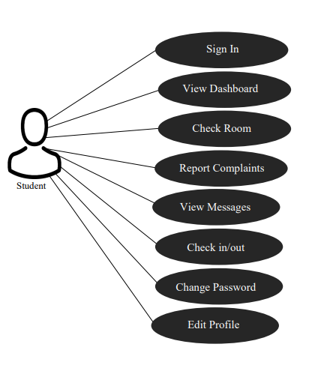

* **Admin Use Case**

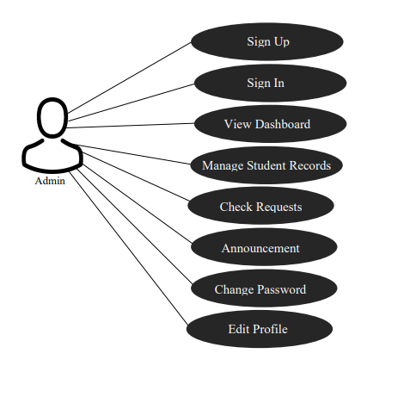

**APPENDIX E**

**Design Diagram**

**Student:**

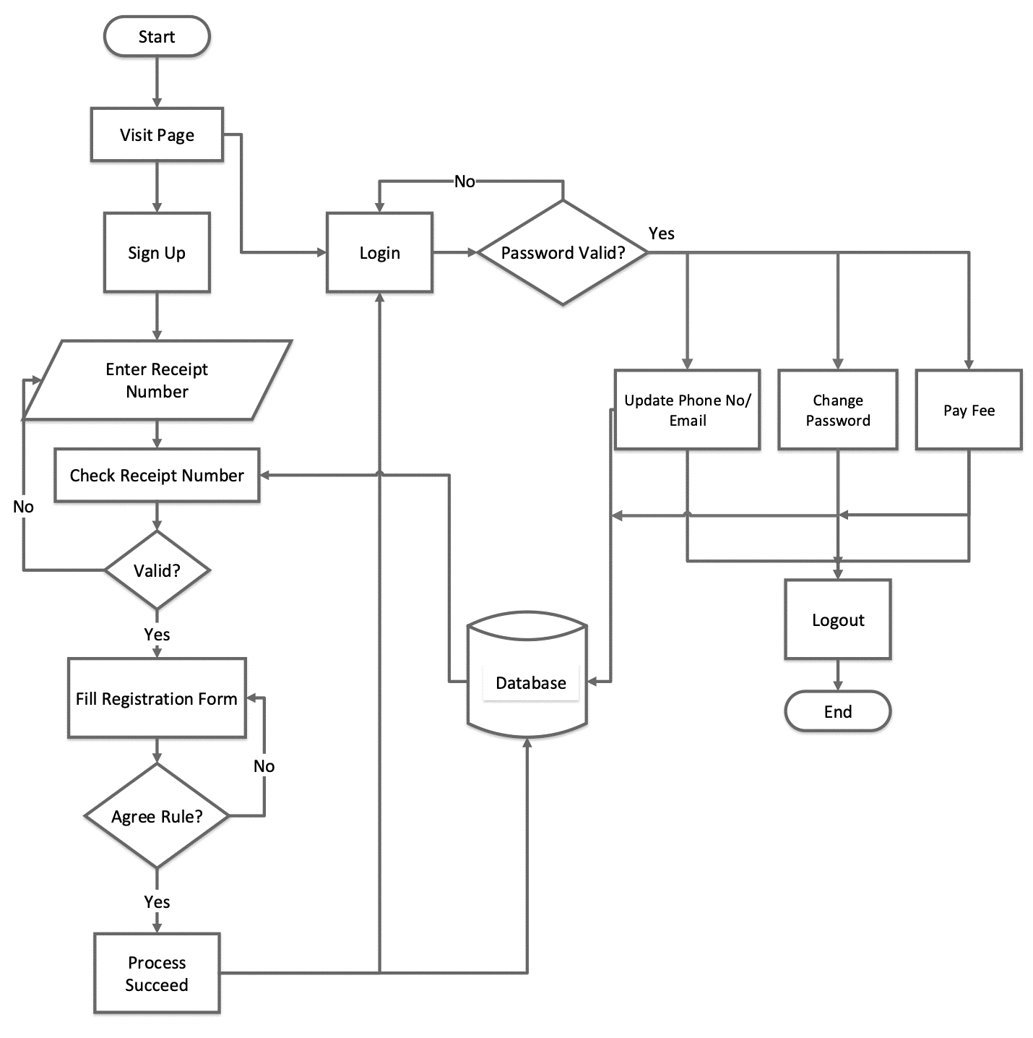

**Admin:**

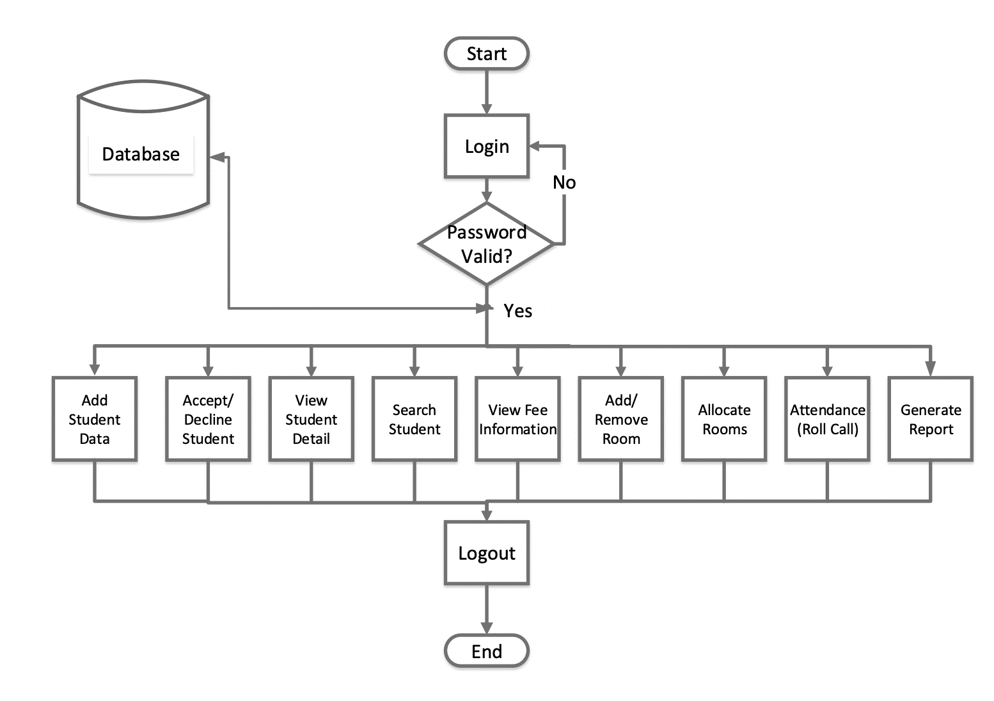

**APPENDIX F**

**Activity Diagram**

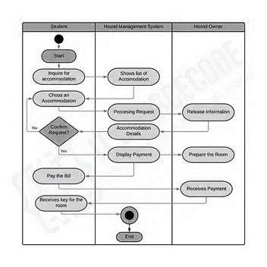

**APPENDIX G**

**Data flow Diagram**

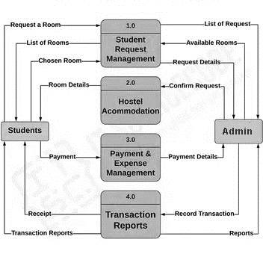

**Appendix H**

**Reliability of the Instrument**

NEW FILE.

Dataset Name Dataset3 Window=Front.

Reliability/Variables=Item1 Item2 Item3 Item4 Item5 Item6 Item7/Scale('Sectiona') All/Model=Alpha.

**Scale: SECTIONA**

|  |  |  |  |
| --- | --- | --- | --- |
| **Case Processing Summary** | | | |
|  | | N | % |
| Cases | Valid | 25 | 100.0 |
| Excludeda | 0 | .0 |
| Total | 25 | 100.0 |
| a. Listwise deletion based on all variables in the procedure. | | | |

|  |  |
| --- | --- |
| **Reliability Statistics** | |
| Cronbach's Alpha | N of Items |
| .684 | 7 |

**Scale: SECTION_B**

|  |  |  |  |
| --- | --- | --- | --- |
| **Case Processing Summary** | | | |
|  | | N | % |
| Cases | Valid | 25 | 100.0 |
| Excludeda | 0 | .0 |
| Total | 25 | 100.0 |
| a. Listwise deletion based on all variables in the procedure. | | | |

|  |  |
| --- | --- |
| **Reliability Statistics** | |
| Cronbach's Alphaa | N of Items |
| -.041 | 7 |

**Scale: SECTION_C**

|  |  |  |  |
| --- | --- | --- | --- |
| **Case Processing Summary** | | | |
|  | | N | % |
| Cases | Valid | 14 | 56.0 |
| Excludeda | 11 | 44.0 |
| Total | 25 | 100.0 |
| a. Listwise deletion based on all variables in the procedure. | | | |

|  |  |
| --- | --- |
| **Reliability Statistics** | |
| Cronbach's Alpha | N of Items |
| .815 | 7 |

**Scale: SECTION_D**

|  |  |  |  |  |
| --- | --- | --- | --- | --- |
| **Case Processing Summary** | | | | |
|  | | N | | % |
| Cases | Valid | 14 | | 56.0 |
| Excludeda | 11 | | 44.0 |
| Total | 25 | | 100.0 |
| a. Listwise deletion based on all variables in the procedure. | | | | |
| **Reliability Statistics** | | | | | |
| Cronbach's Alpha | | | N of Items | | |
| .845 | | | 4 | | |